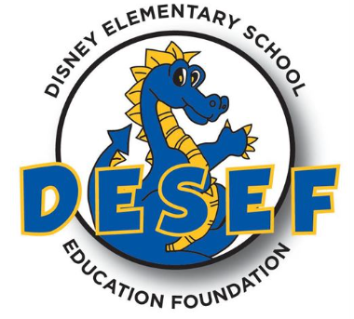

Dear Friends,

I am a parent and volunteer writing on behalf of the Disney Elementary School Education Foundation (DESEF), a non-profit fundraising organization (Tax ID# 20-3046825) created and run by the parents of San Ramon’s Walt Disney Elementary. Our purpose is to raise money to pay for programs, personnel, equipment, and services not funded by our school district as San Ramon Valley Unified School District is one of the lowest funded districts in the state of California.

A critical fundraiser for our school each year is our Auction. All the funds raised at this event directly support our students and teachers. DESEF funds our librarian, music program, teacher grants and equipment, literacy materials, paraprofessionals, and our academic intervention program.

Your help is needed to help us continue funding critical school programs. Please support our students by donating items or gift certificates from your business.

Donation deadline: All donations need to be received by February 20th, 2024

Walt Disney Auction Dates: March 2-8 2024

In return for your tax-deductible donation, we will promote your business on our online Auction website which is marketed to local families of our 600+ students. In addition, your online auction listing will link to your website. Sponsorship and advertising opportunities are also available!

Thank you for your consideration. Together we can truly make a difference!

Sincerely,

Melissa Bowen, 23-24 Auction Director [Desefauction@gmail.com](mailto:Desefauction@gmail.com)

--------------------------------------------------------------------------------------------------------------------------------- **DONATION FORM: *Please keep a copy of this form as your tax receipt.***

**Print your information as you would like it to appear in the auction catalog:**

Company/Donor Name: ____________________________________________________________________________ Contact Name: _______________________________________________Phone: _____________________________ Mailing Address: _________________________________________________________________________________ Email: ____________________________________ Website address: ______________________________________ Description of item being donated: ___________________________________________________________________ Restrictions on donation (expiration dates, etc.): ________________________________________________________ Fair market value of donation: __________________

Please mail or e-mail all correspondence to:

DESEF

PO BOX #1981 San Ramon, CA 94583

desefauction@gmail.com

Disney Elementary School Education Foundation ● https://wdes.srvusd.net/Families/DESEF/index.html